**Excel IF Function**

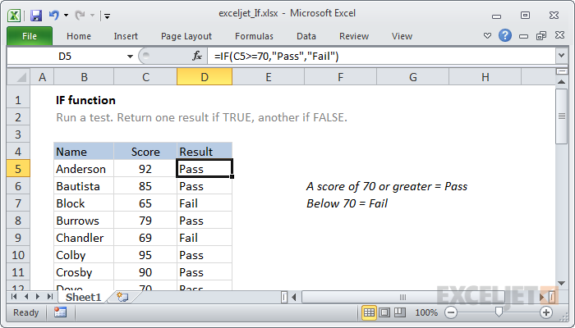

Summary

The IF function can perform a logical test and return one value for a TRUE result, and another for a FALSE result. For example, to "pass" scores above 70: =IF(A1>70,"Pass","Fail"). More than one condition can be tested by nesting IF functions. The IF function can be combined with logical functions like AND and OR.

Purpose

Test for a specific condition

Return value

The values you supply for TRUE or FALSE

Syntax

=IF (logical_test, [value_if_true], [value_if_false])

Arguments

* **logical_test** - A value or logical expression that can be evaluated as TRUE or FALSE.
* **value_if_true** - [optional] The value to return when logical_test evaluates to TRUE.
* **value_if_false** - [optional] The value to return when logical_test evaluates to FALSE.

Usage notes

Use the IF function to test for or evaluate certain conditions, and then react differently depending on whether the test was TRUE or FALSE.

For example, let's say you want to assign either "Pass" or "Fail" to students based on a test score. In that case, you need to test the sore itself (for each student) and then return either "Pass" or "Fail".

If you had a score in cell C6, and you wanted to test this score to see if is at least 70, you would use this:

=C6>=70

This translates as "C6 contains a value greater than or equal to 70". It will either be TRUE or FALSE, depending on the value in C6. You then supply a value that the IF function should return if the test is TRUE, and a value to use if the test is FALSE.

Putting it all together, you would use this formula:

=[IF](https://exceljet.net/excel-functions/excel-if-function)(C6>=70, "Pass", "Fail")

This is the formula that appears D6 in the example shown. When it is copied down the column, it will test every score and return the correct result.

**Nested IF statements**

You may here the term "Nested IF" or "Nested IF statement". This refers to using more than one IF function so that you can test for more conditions and return more possible results. Each IF statement needs to be carefully "nested" inside another so that the logic is correct.

For example, the following formula can be used to assign an grade rather than a pass / fail result:

=[IF](https://exceljet.net/excel-functions/excel-if-function)(C6<70,"F",[IF](https://exceljet.net/excel-functions/excel-if-function)(C6<75,"D",[IF](https://exceljet.net/excel-functions/excel-if-function)(C6<85,"C",[IF](https://exceljet.net/excel-functions/excel-if-function)(C6<95,"B","A"))))